Khrystian Clark

CS-225: Discrete Structures in CS

Homework 9, Part 1

Exercise Set 1.4 of the required textbook: Problem #9

Exercise Set 4.9 of the required textbook: Problem #13, #15(a, b)  #21.c, #23.e, #24.c

Set 1.4:

9.

i) Find all edges that are incident on $v_{3}=e_{1},e_{2},e_{7}$

ii) Find all vertices that are adjacent to $v_{3}=v_{1},v_{2}$

iii) Find all edges that are adjacent to $e_{1}= e_{2}, e_{7}$

iv) Find all loops = $e_{1}, e_{3}$

v) Find all parallel edges = $e_{4}, e_{5}$ vi) Find all isolated vertices = v4

vii)Find the degree of v3 = 2

Set 4.9:

13. A simple graph with 9 edges and all vertices of degree 3:

By theorem 4.9.1, the Handshake Theorem

G = 2× 9 = 18

If all vertices have degree 3, then 18/3=6 vertices

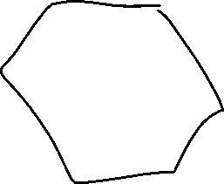

15.

a) The fact that this states only one scenario in the 41 pairs of network friends (82 total people) in which one person is friends with five others, and everyone else in groups of 3 or more, then 82-5 = 77 peoples are network friends with at least three others.

b) 41 network pairs of friends = 41× 2=82 total.

21. c) No. Because once there are at least 5 vertices, then there are at least a total of 10. Then the way the degrees can be measured is G = 2+3+4+5+1, since each vertex has a different degree we can assume and start from the smallest degree and simply count up for 5vertices. 1+2+3+4+5=15 which creates more than 10 degrees in the graph.

23. e)

24. c)



